# The Britches Full Of Stitches

**Aherlow Set Page 1**

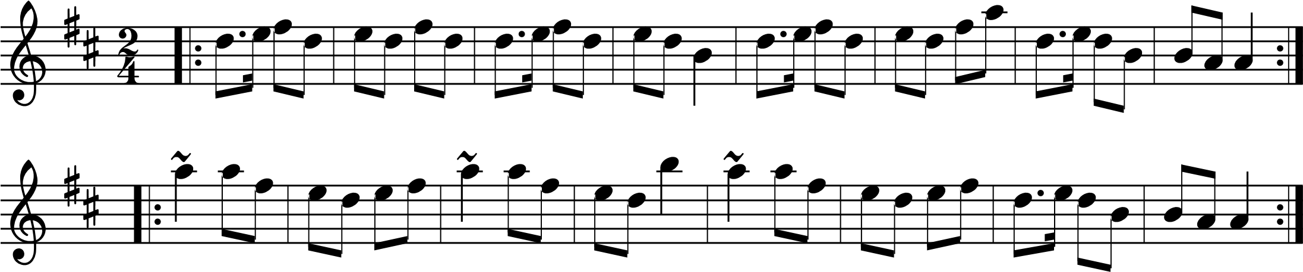

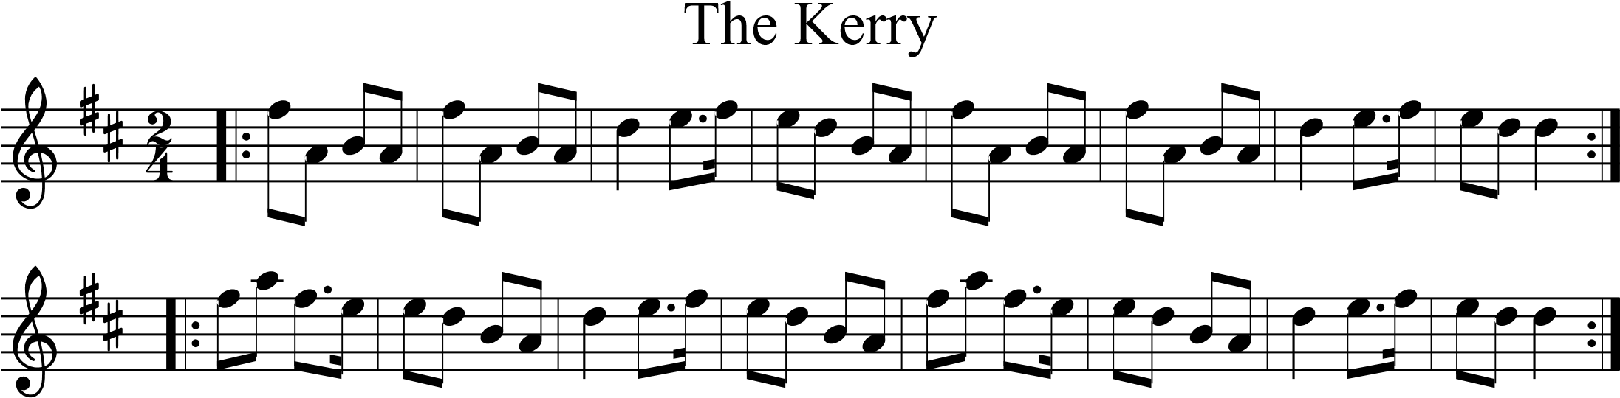

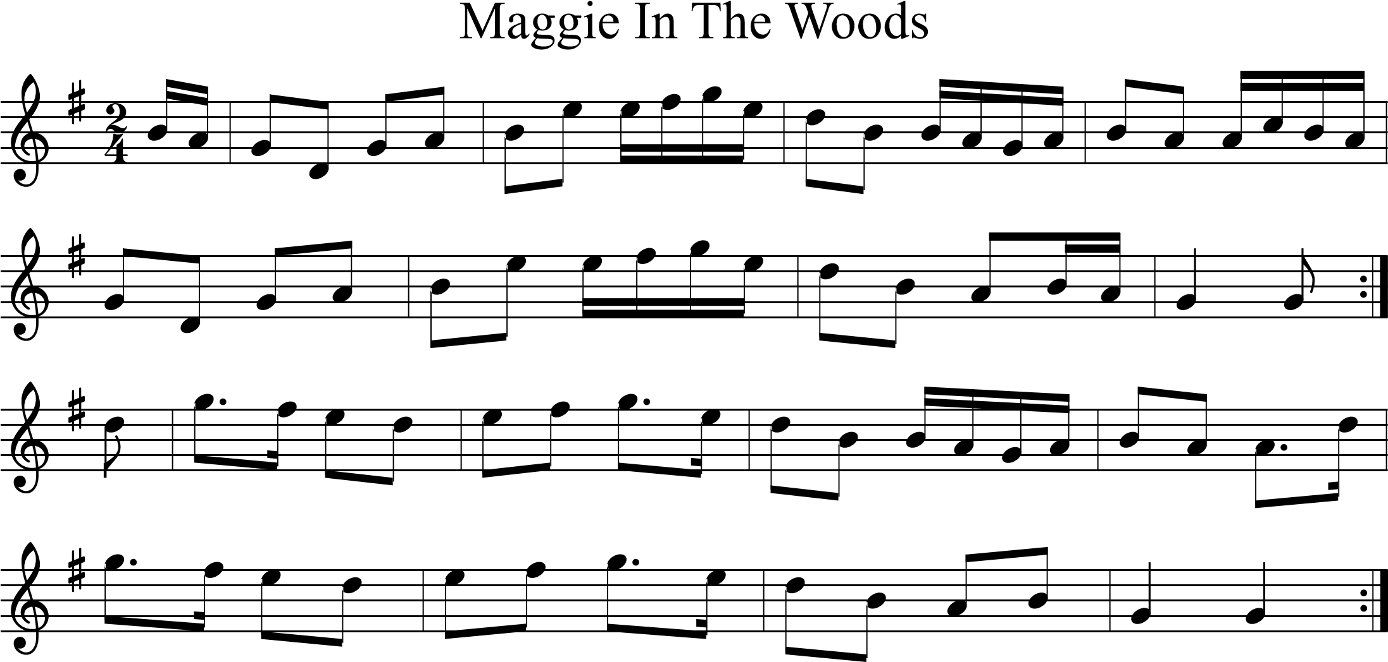

# The Ballydesmond

**Aherlow Set Page 2**

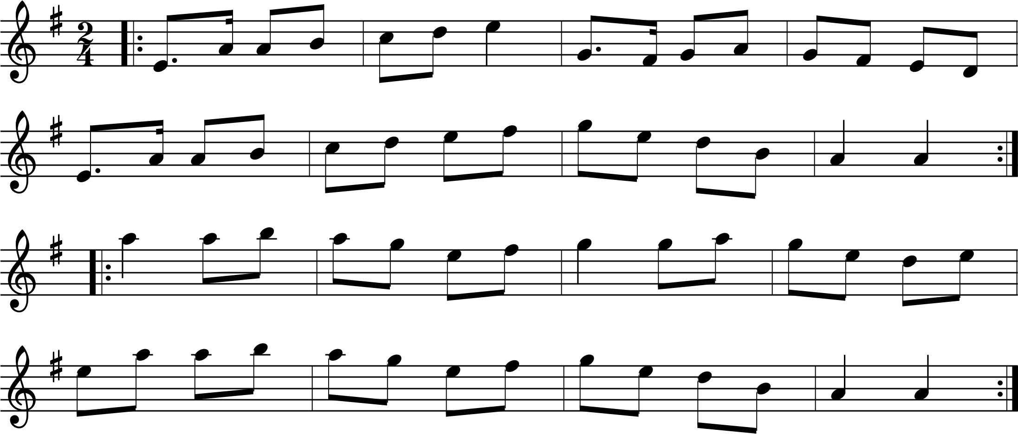

**Pride of Erin Waltz Page 1**

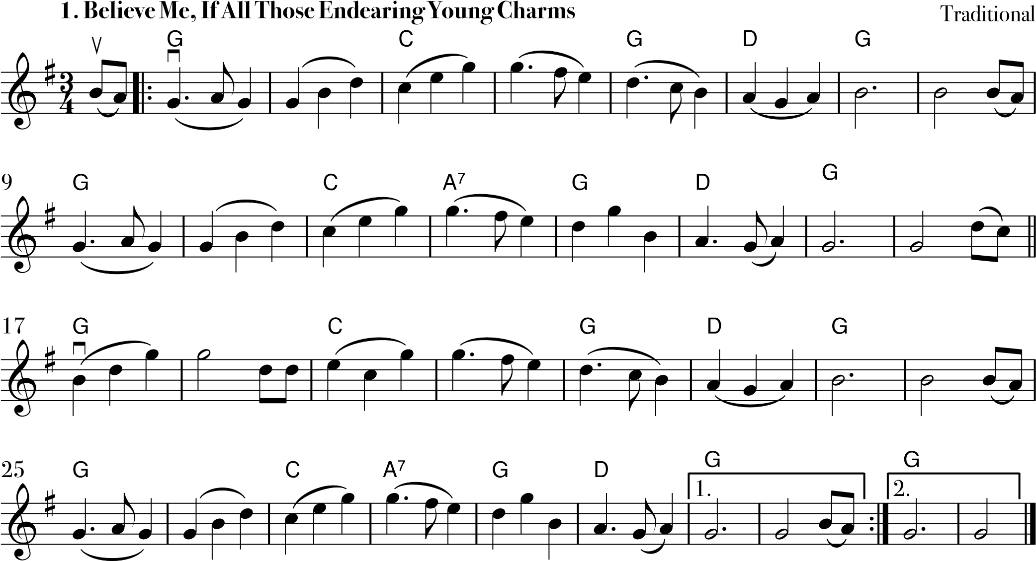

**!**

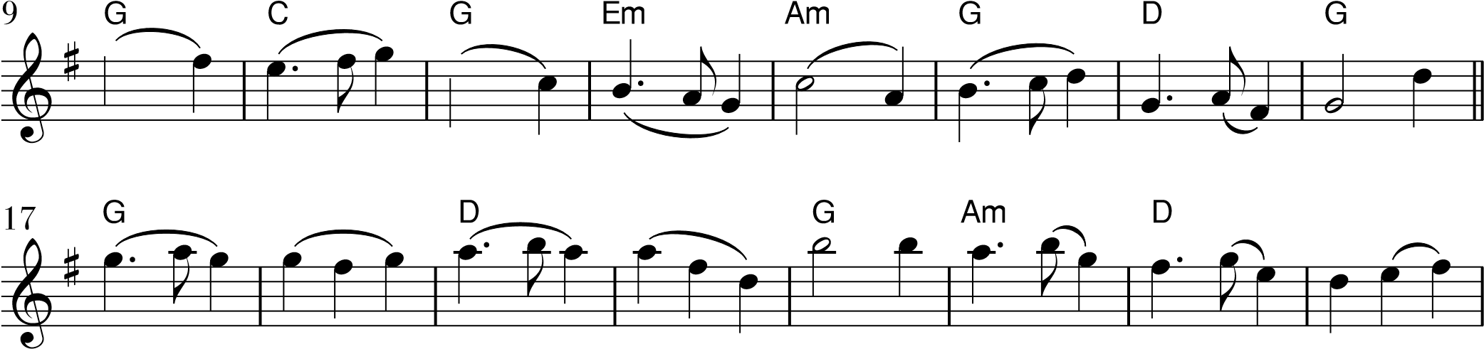

&

**Pride of Erin Waltz Page 2**

.

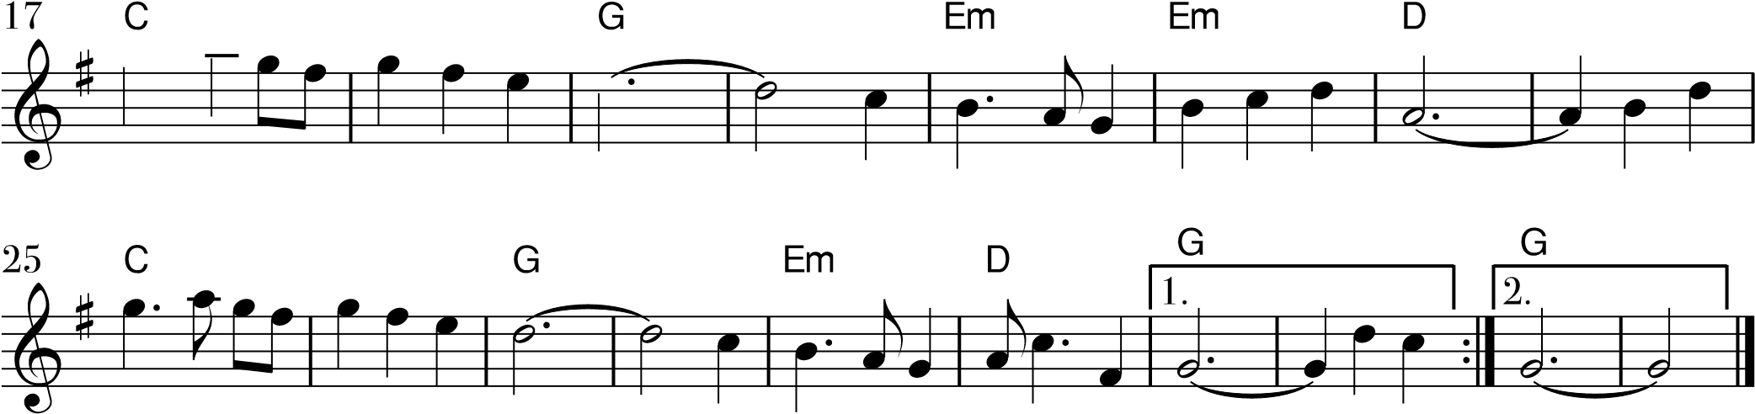

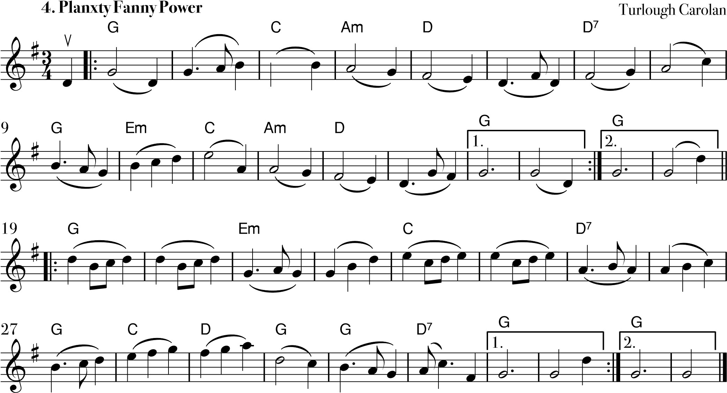

The Walls Of Limerick

**Walls of Limerick Page 1**

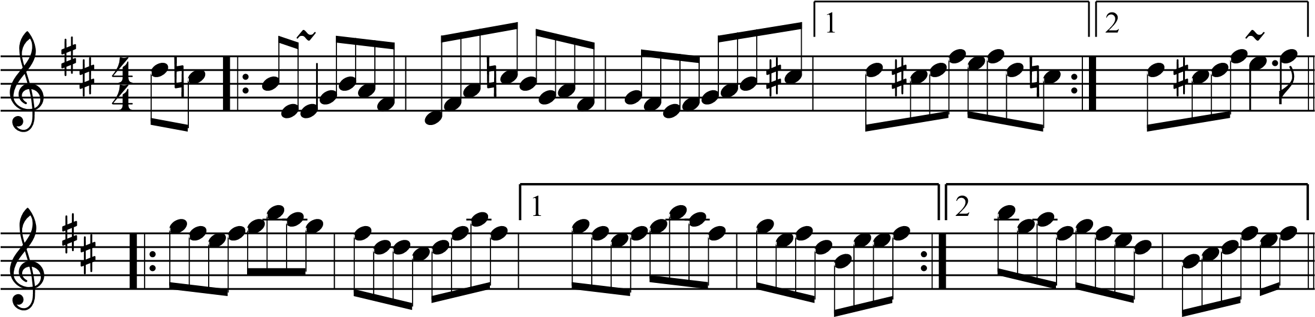

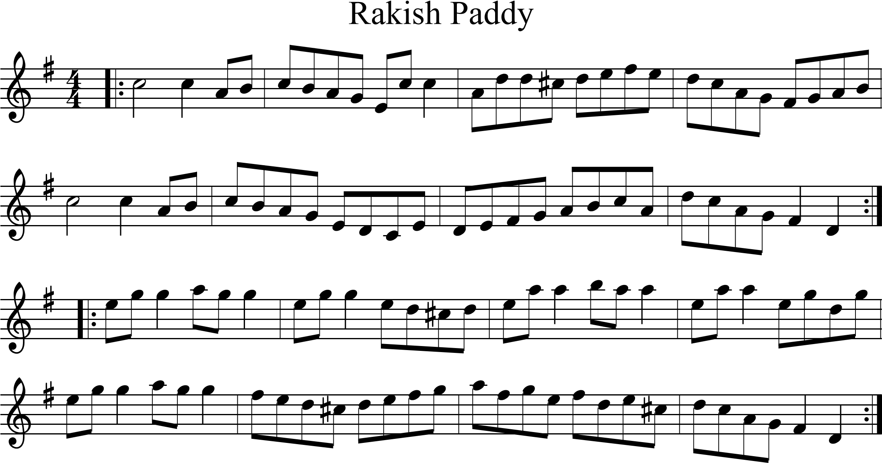

**Walls of Limerick Page 2**

# The Cedars Of Lebanon

1

2

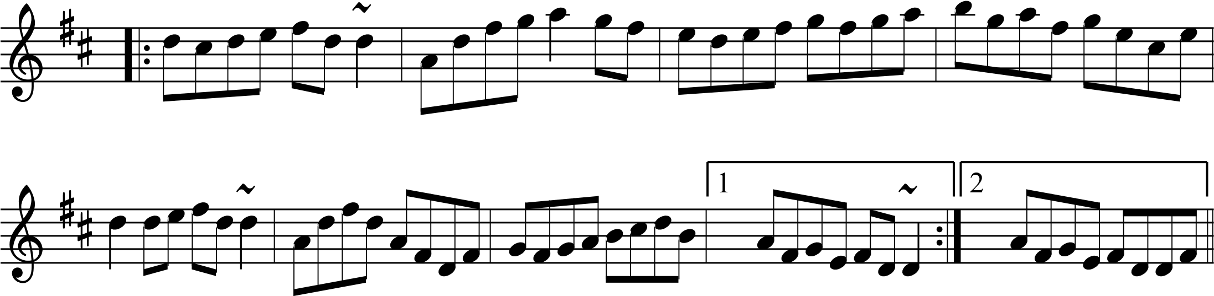

The Kerry

**The Siege of Ennis Page 1**

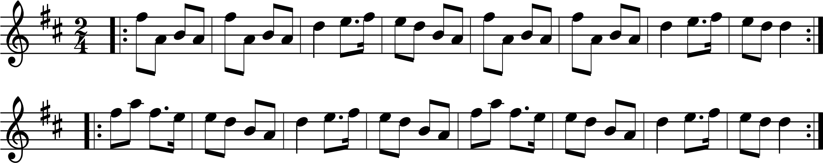

# The Siege Of Ennis

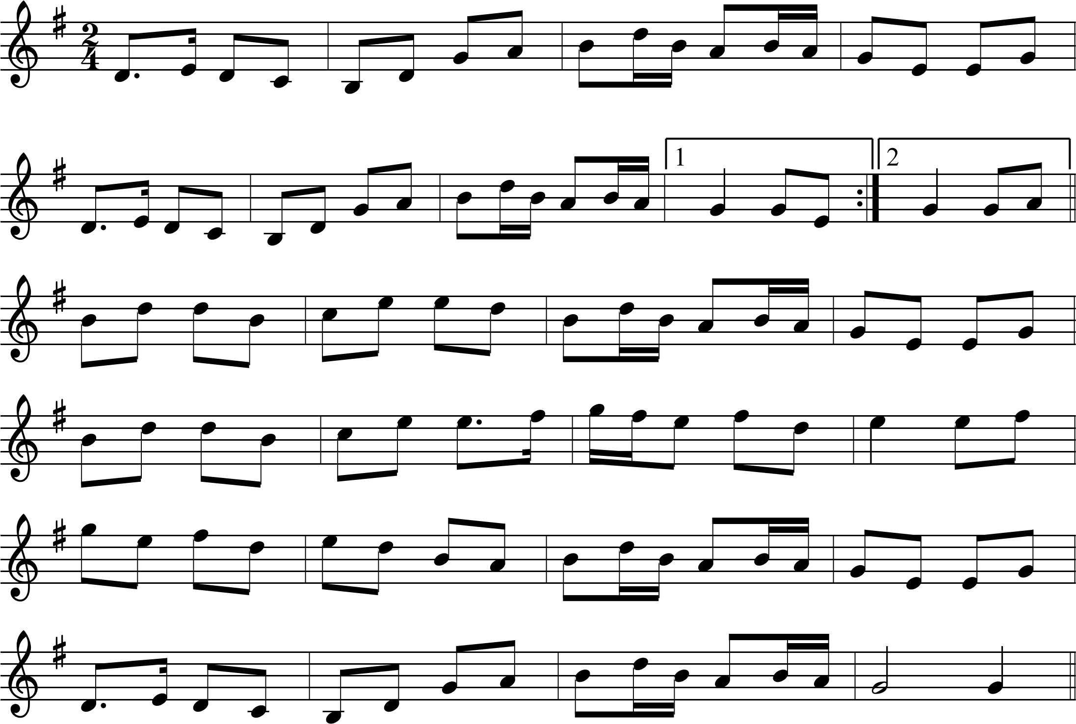

# The Britches Full Of Stitches

**The Siege of Ennis Page 2**

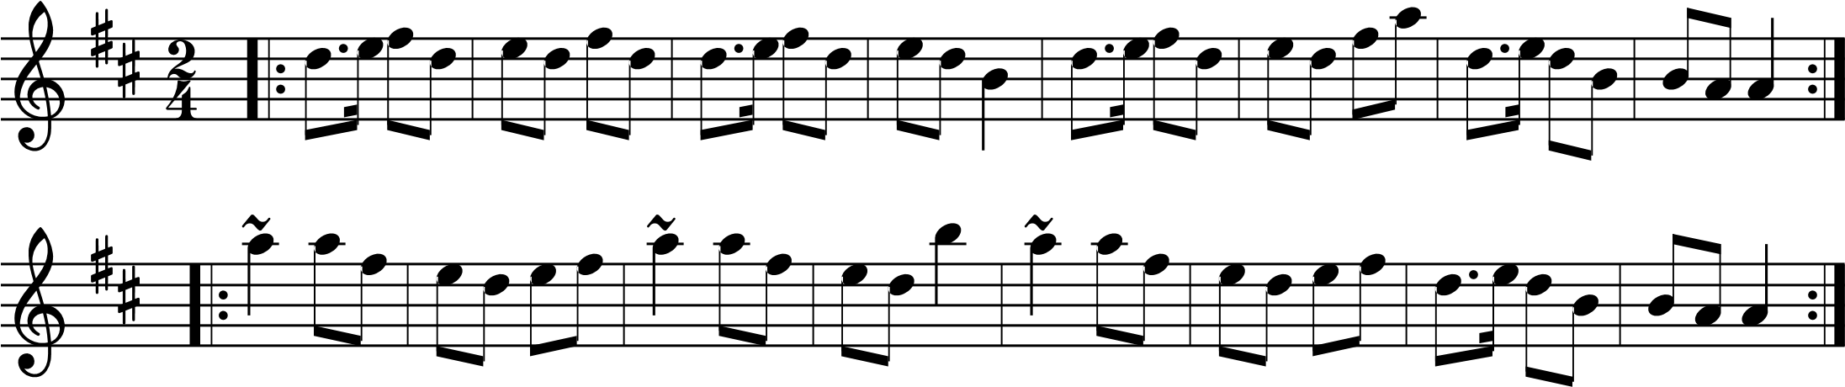

**The Haymakers Jig Page 1**

# The Swallowtail

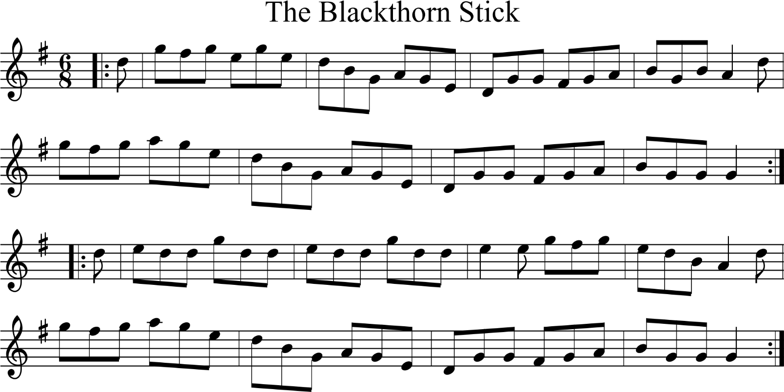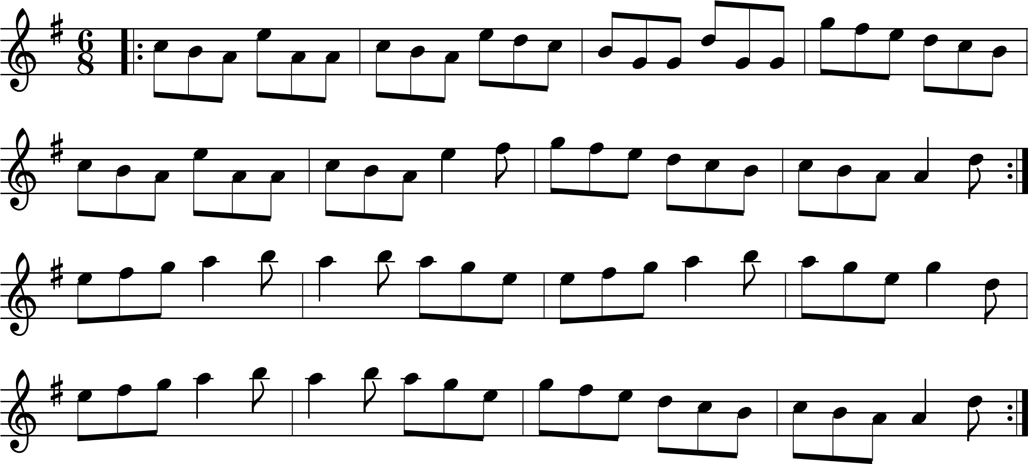

**The Haymakers Jig Page 2**

The Haymaker's

The Fairy

**The Fairy Reel Page 1**

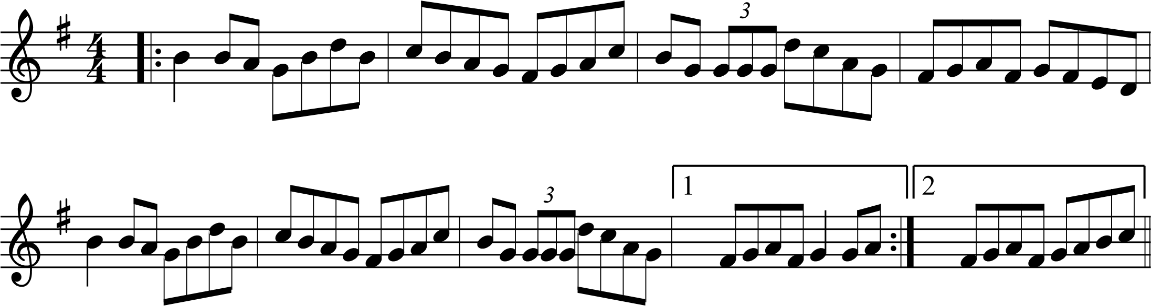

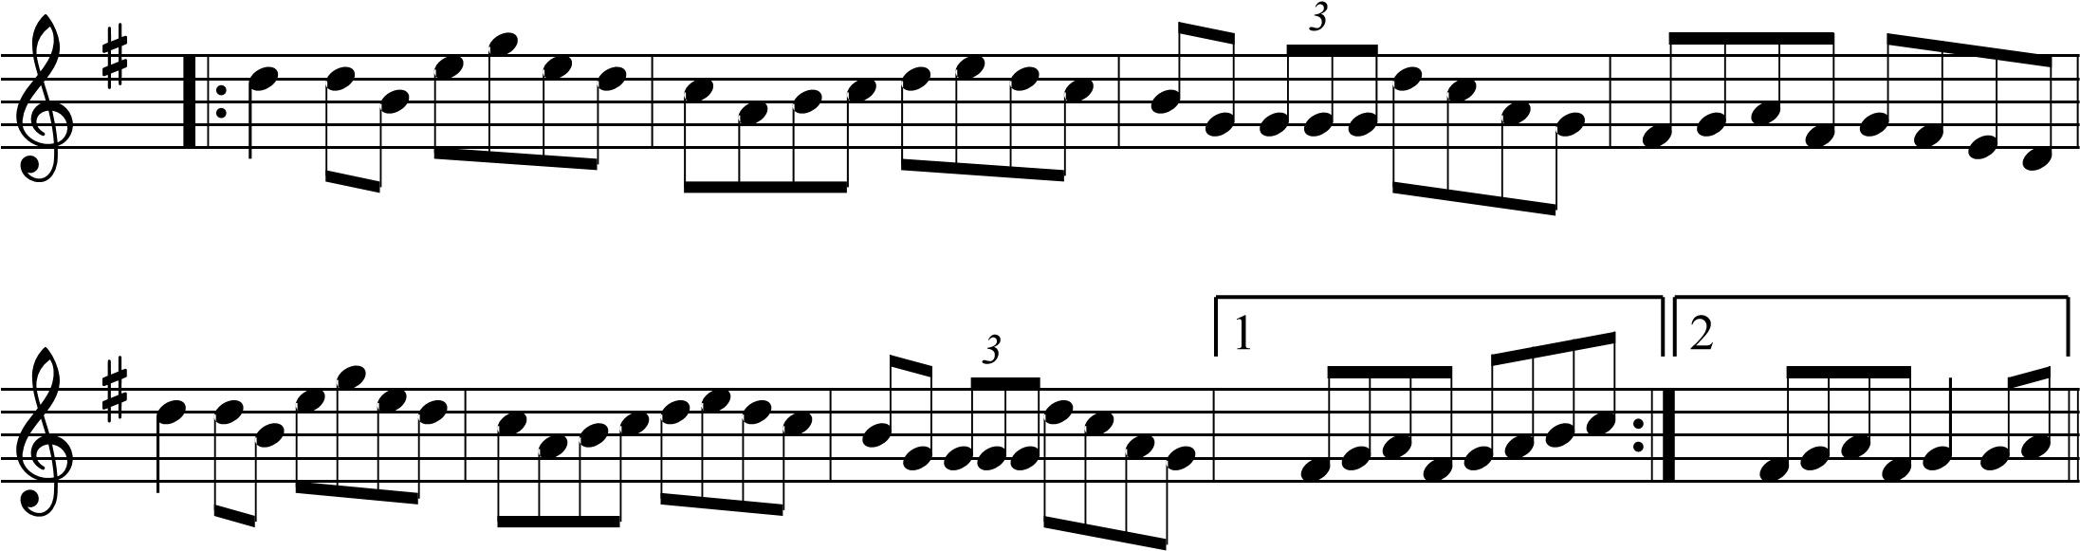

# The Enchanted Lady

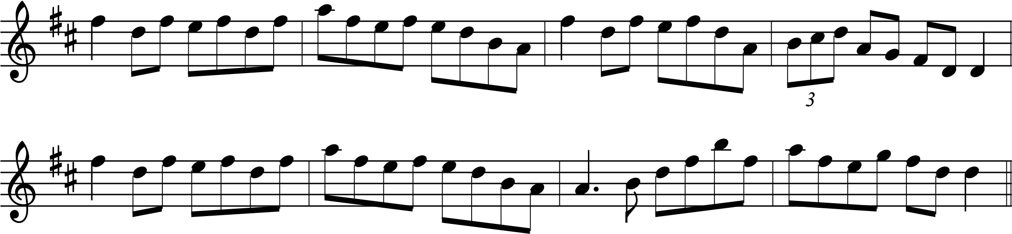

**The Fairy Reel Page 2**

# The Holy Land

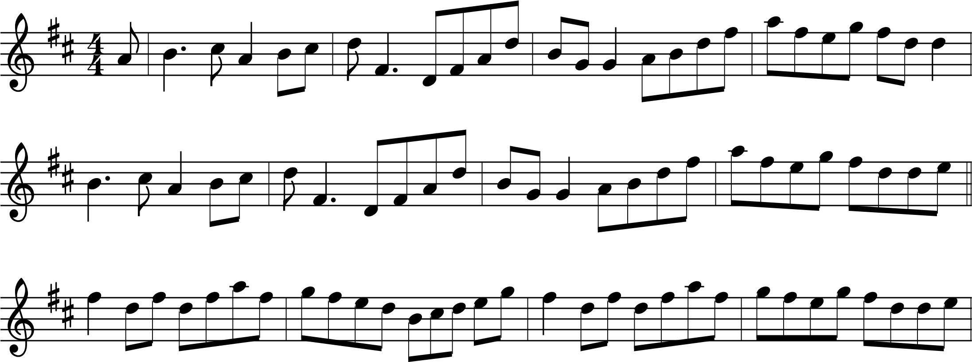

*3*

*3*

**Galway Reel Page 1**

The Ashplant

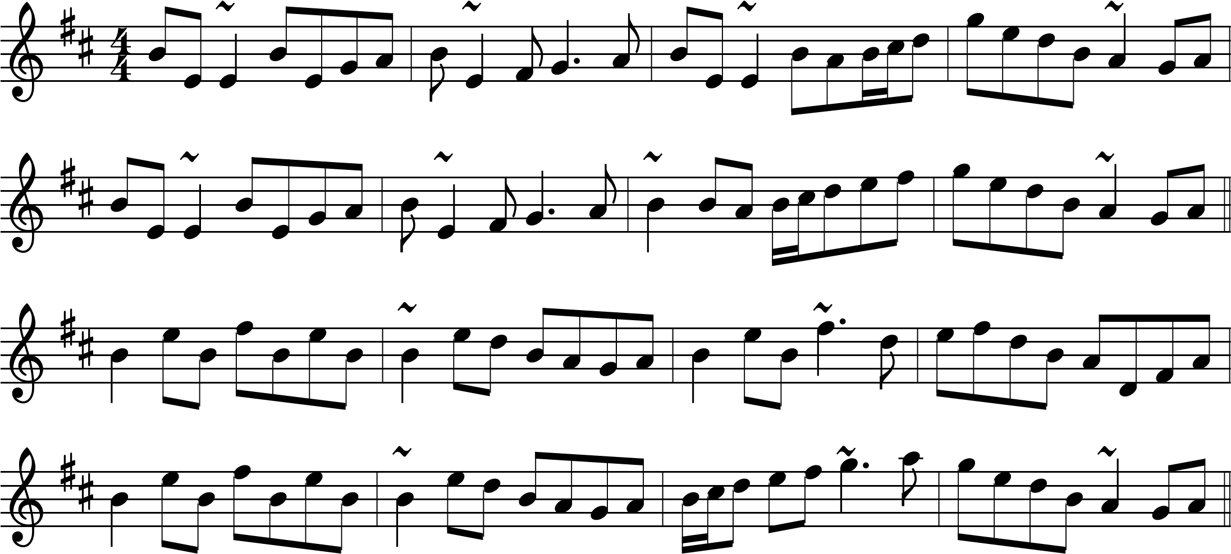

# Jenny Nettle's Fancy

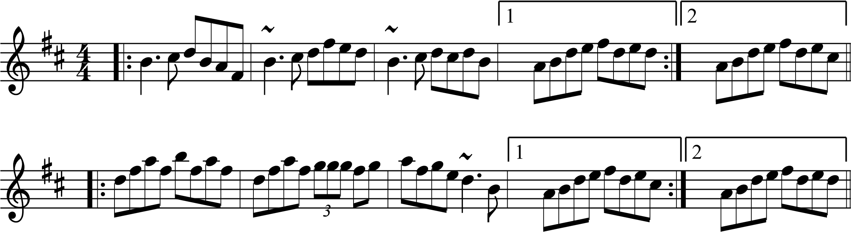

# Tommy Peoples'

**Galway Reel Page 2**

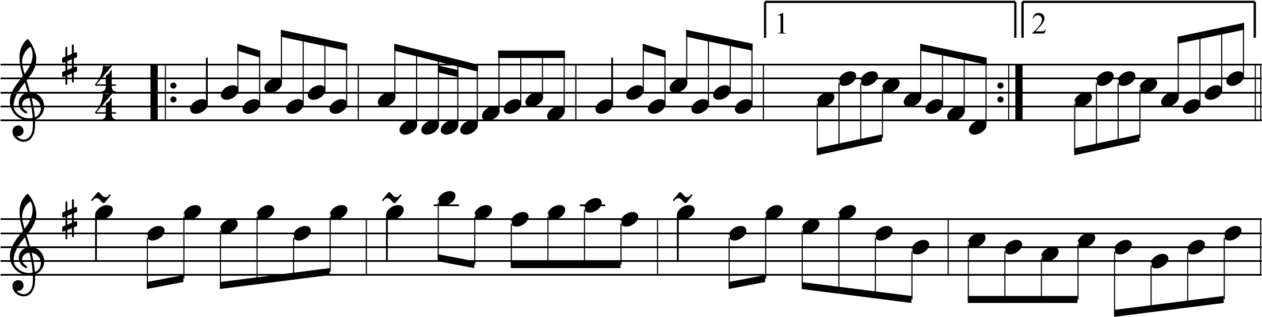

The Parting Glass

